

Bluetooth Wireless Mouse

User guide

**About this manual**

* This user manual is specially designed to detail the functions and features of Lenovo mouse
* Please read this manual before using the mouse to ensure safe and proper use.
* The description in this manual describes the procedures for using a Lenovo Bluetooth Wireless Mouse to a laptop

**Note:**

The mouse is supported on the following operating systems:

* Microsoft Windows XP (32-bit)
* Microsoft Windows Vista (32-bit or 64-bit)
* Microsoft Windows 7 (32-bit or 64-bit)
* Microsoft Windows 8 (32-bit or 64-bit)
* Microsoft Windows 8.1 (32-bit or 64-bit)
* Microsoft Windows 10 (32-bit or 64-bit)

**Table of contents:**

* Product description
* Installing the batteries
* Installing the mouse

**Product description:**

The following image shows the front view and rear-view image of the Bluetooth Wireless Mouse

Front view of the wireless mouse:

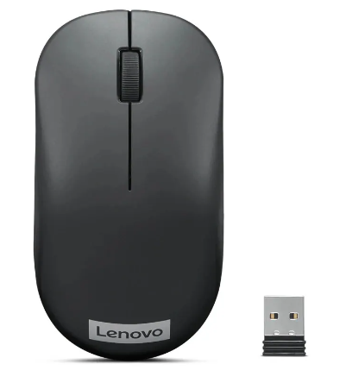

USB (universal serial bus) receiver

left click

Right click

Scrolling button

Rear-view of the wireless mouse:

Power button

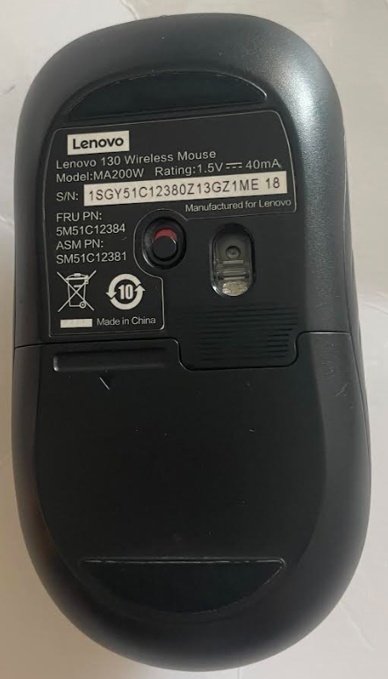

Laser output

Battery compartment

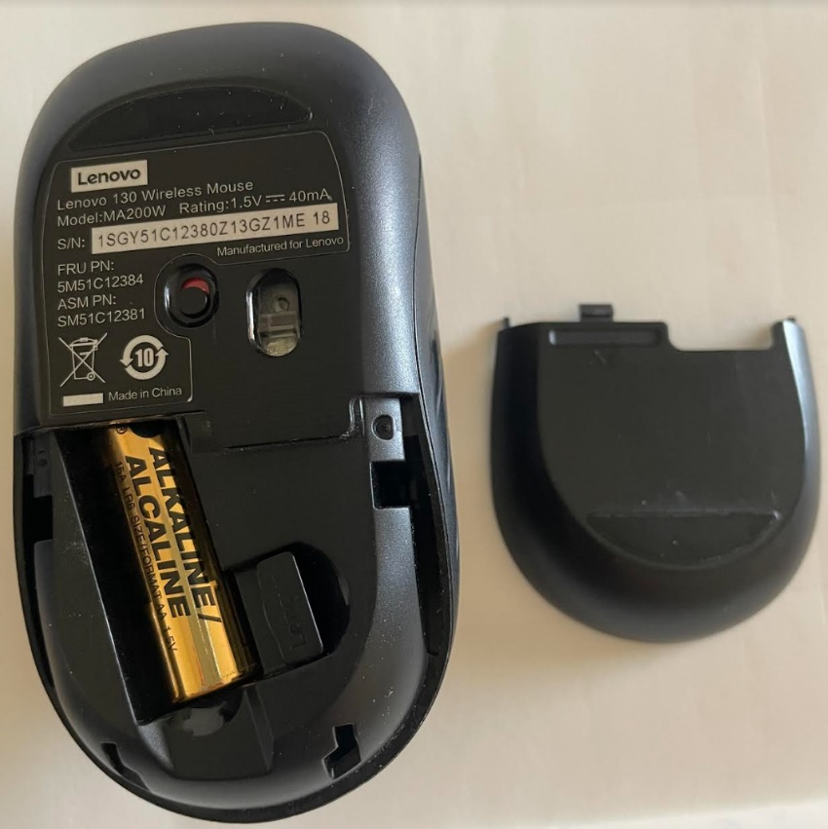

USB (universal serial bus) receiver

Laser output

Power button

Battery compartment cover

AA battery

**Installing the batteries**

* Open the Battery compartment and Install AA batteries
* Pull out he USB receiver from the Battery compartment
* Close the Battery compartment with Battery compartment cover
* Switch ON the Power button
* The laser output starts blinking with red light

**Installing the mouse**

* Connect the USB receiver to the laptop USB port (provided on the side or the rear of the laptop)
* scroll to check the mouse connection